Sounds Like Fun Contract

Client:
Gary Bishop

Contractors:
Eden Kung
Matt Clark
Patrick Dwyer
Daniel Evans

General Description:
The goal of this project is to create a game that is accessible and enjoyable to visually impaired children.

A brief description of the game is as follows:
- The game will be a racer in which the player switches, left and right, between three different tracks in order to collect coins, avoid obstacles, and get to the finish line intact. Speed up if you’re feeling confident, slow down if you hit a rough patch. Play for locally-saved high scores.
- The game will use OpenGL for graphics, fmod for sound, and Microsoft Speech for text-to-speech code.
- Here’s an artist’s depiction of the basic gameplay
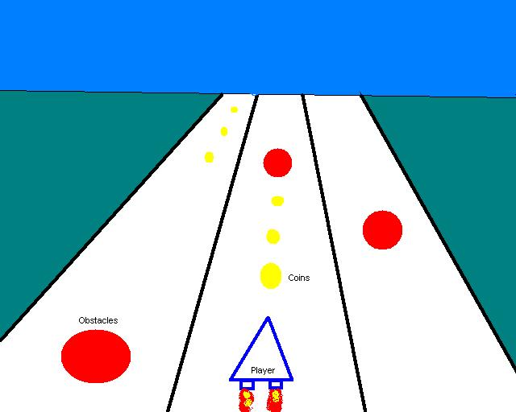

Contractor and Client Obligations:
The party of Eden Kung, Matt Clark, Patrick Dwyer, and Daniel Evans shall henceforth be collectively referred to as ‘the Contractor.’ The party of Gary Bishop shall be henceforth known as ‘the Client.’ The Contractor agrees to provide the Client with a functional software package that meets the specifications defined under the Primary Requirements section. The Contractor agrees to deliver the final version of this software no later than April 27, 2004.

If the Primary Requirements are met before April 27, 2004, additional software features, described under secondary and tertiary objectives, will be delivered no later than April 27, 2004. However, the Contractor’s formal obligation is to meet the Primary Requirements, and furthermore, there is no obligation (explicit or implicit) to meet the Secondary Requirements or Tertiary Requirements.

Meetings:
We will meet with the Diane Pozefsky once a week to discuss our progress and any concerns we have. We will demo all deliverables to Gary Bishop when they are available.

Requirements:
Please refer to the Design Document for all features and their classification (primary, secondary). Below are the more important features.

Primary Objectives:
- Simple, playable game model with no options to set. Please refer to General Description above for basic game model
- Works on Windows 98, 2000, XP (those that are compatible with our resources)
- Requires headphones
- Downloadable
- Documentation so that anyone can understand and expand on our code
- Audio instructions so that anyone can play
- Not supporting new levels

Secondary Objectives:
- Randomized levels
- Works on Windows 95

Resources:
- Fmod
- Windows SDK
- OpenGL
- Visual Studio .NET C++
- Clients to test program

Risks:
- Perceiving spatial sounds may be difficult

Signatures:

________________________________________ Date_____________

Diane Pozefsky – Boss

________________________________________ Date_____________

Gary Bishop – Client

________________________________________ Date_____________

Eden Kung – Contractor

________________________________________ Date_____________

Matt Clark – Contractor

________________________________________ Date_____________

Patrick Dwyer – Contractor

________________________________________ Date_____________

Daniel Evans - Contractor

